DAMG 6210 – Sec 03 – Project 2 – Group 6

# Team members:

* Netra Awate
* Simran Bhatia
* Pavan Kumar Kora
* Ashwin Krishnan Meialagan
* Kousalyaa Senthilvel
* Prasanth Subburaj

# Project Topic:

Database Design for Booking Rental Co-working Spaces

# Objectives:

This database design enables users who are individual workers (customers) to find a co-working office space nearby and book it for a certain period defined by the customer. Office or buildings will be posted by their owners with the name of rental, available time, address, photo, rental rate, and available spots.

To create a database for an office space rental company that has the features listed below:

* Customers must be able to register and have their credentials recorded, including company name, username, email, password, payment information and home address.
* Business users must be able to register and have their credentials recorded, including username, email, password, payment information and home address.
* All users should be able to login using their username and password.
* Business Users must be given the ability to register new coworking spaces with details including name of rental, available time, address, photo (URL), rental rate, capacity, whether they are renting n spots or whole office.
* Business users must be allowed to withdraw coworking space listings and make changes to some details such as name of rental, available time, rental rate, photo, capacity, whether they are renting n spots or whole office.
* Customers must be allowed to reserve a co-working space for a specific time.
* Customers must be allowed to cancel their reservations.
* Customers should be able to see their current reservation and previous booking history.
* Customers must be able to view available listings with the available timeframes.
* Customers must be able to filter available listings on some specific criteria, like whether or not a rental space has internet available, available spots, etc.
* Customers must be allowed to leave reviews about the services.
* Customers must be allowed to report incidents if they encounter any.
* Customers should be able to sort listings

# Problem Statement:

Budding startups and freelancers often forgo spending large amounts of money on an office setup in order to establish a designated workplace. However, working remotely comes with its own pains of blurred boundaries, lost concentration and myriad distractions. Using temporary office spaces for a few hours is the perfect solution to their dilemma.

1. It’s inefficient and time-consuming to log onto different platforms to look at what co-working spaces they have available.
2. It is frustrating to manage different login and credentials for each platform.
3. Overbooking and conflicting bookings can cause issues and waste time.
4. To avoid inconsistency and double booking, a single platform is ideal.

# Problem Solution:

Following are the solutions derived by the database design model for the proposed problem case:

1. A Business User profile will be created with all the attributes from **OWNER**, and the rental posted by the owner with location details will be added to the **RENTAL** table.
2. A Customer profile will be created with all the attributes required for the **CUSTOMER** table, including but not limited to first name, last name, and contact details.
3. To ensure the transaction of money for booking a rental space, the customer must add credit card details as per **CUSTOMER_CARD_DETAILS.**
4. Customers can view rental listing information from the **RENTAL _POSTING** table
5. Customers can book a space by filtering with specific attributes like location, date, or time.
6. Customers can edit their bookings from their rental history.
7. Customers can cancel their bookings from their rental history.
8. Customers can add a review or lodge a complaint about a rental once the booking duration is completed and the records will be stored in **RENTAL_FEEDBACK** or **RENTAL_COMPLAINT** tables respectively.

## Logical Diagram:

# Database Design Decisions:

* A customer can book a space for 1 person or a group of people as per the seat availability as mentioned in the rental space posting under attribute **r_totalseatspace.**
* The customers can log in to their account and view their active rental details from **RENTAL_BACKLOG** table.
* Customers can file a complaint which will be addressed by the owners to improve future co-working postings.

## Data Model ER Diagram:

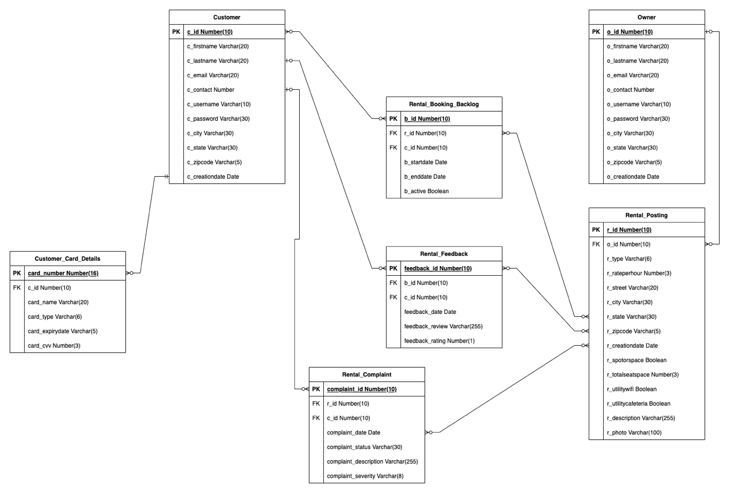

## Facts:

* All rentals are directly posted by owners without any broker.
* A customer can book a space only once for the given period of time.
* Customers won’t be allowed to book a rental after the space availability of rental is exceeded.
* Customers cannot book a space without credit card details, booking for a group of people will also require credit card details for all.

## Assumptions:

* The customer should book a rental space for a minimum of 2 hours.
* Customers cannot be owners to rent the space further.

## Database Identification:

Following are the entities with their attributes and description to build database design:

### Customer:

|  |  |  |  |
| --- | --- | --- | --- |
| **Attributes** | **Datatypes** | **Constraints** | **Description** |
| c_id | Number(10) | Primary Key | Unique identifier for each customer |
| c_firstname | Varchar (20) | Not Null | Customer’s first name |
| c_lasttname | Varchar (20) | Not Null | Customer’s last name |
| c_email | Varchar (20) | Not Null, Unique | Unique customer email |
| c_contact | Number(10) | Not Null, Unique | Unique customer phone number |
| c_username | Varchar (10) | Not Null, Unique | Unique customer username for login |
| c_password | Varchar (30) | Not Null | Unique customer password for login |
| c_city | Varchar (30) | Not Null | Customer’s city of residence |
| c_state | Varchar (30) | Not Null | Customer’s state of residence |
| c_zipcode | Varchar (5) | Not Null | Customer’s zip code of residence |
| c_creationdate | DATE | Default SYSDATE | Default SYSDATE to view customer profile creation date |

### Owner:

|  |  |  |  |
| --- | --- | --- | --- |
| **Attributes** | **Datatypes** | **Constraints** | **Description** |
| o_id | Number(10) | Primary Key | Unique identifier for each owner |
| o _firstname | Varchar (20) | Not Null | Owner’s first name |
| o_lasttname | Varchar (20) | Not Null | Owner’s last name |
| o_email | Varchar (20) | Not Null, Unique | Unique owner email |
| o_contact | Number | Not Null, Unique | Unique owner phone number |
| o_username | Varchar (10) | Not Null, Unique | Unique owner username for login |
| o_password | Varchar (30) | Not Null | Unique owner password for login |
| o_city | Varchar (30) | Not Null | Owner’s city of residence |
| o_state | Varchar (30) | Not Null | Owner’s state of residence |
| o_zipcode | Varchar (5) | Not Null | Owner’s zip code of residence |
| o_creationdate | DATE | Default SYSDATE | Default SYSDATE to view owner profile creation date |

### Rental_Posting:

|  |  |  |  |
| --- | --- | --- | --- |
| **Attributes** | **Datatypes** | **Constraints** | **Description** |
| r_id | Number(10) | Primary Key | Unique identifier for each rental |
| o _id | Number (10) | Foreign Key | Owner identifier o_id from OWNER table to map with rental posting table |
| r_type | Varchar (6) | Not Null | Rental types : Office, Café, Studio |
| r_rateperhour | Number(3) | Not Null | Rental’s hourly rate per entity |
| r_street | Varchar (20) | Not Null, Unique | Rental’s street address |
| r_city | Varchar (30) | Not Null | Rental’s city address |
| r_state | Varchar (30) | Not Null | Rental’s state address |
| r_zipcode | Varchar (5) | Not Null | Rental’s zip code |
| r_creationdate | DATE | Default SYSDATE | Default SYSDATE to view owner rental posting creation date |
| r_spotorspace | Boolean | Not Null | 0 if single spots are available or 1 for the whole office |
| r_totalseatspace | Number(3) | Not Null | Total number of seats available for customers to occupy when renting by spot, else 0 |
| r_utilitywifi | Boolean | Not Null | Does the rental space provide wifi for the occupants? |
| r_utilitycafeteria | Boolean | Not Null | Does the rental space have a cafeteria for the occupants? |
| r_description | Varchar (255) | Not Null | Description posted by owner for the rental space |
| r_photo | Varchar(100) |  | URL linking to photo of rental (optional) |

### Rental_Booking_Backlog:

|  |  |  |  |
| --- | --- | --- | --- |
| **Attributes** | **Datatypes** | **Constraints** | **Description** |
| b_id | Number (10) | Primary Key | Booking history identifier b_id for bookings by all customers |
| r_id | Number (10) | Foreign Key | Rental unique identifier r_id from RENTAL POSTING BACKLOG table to map with rental booking table |
| c_id | Number (10) | Foreign Key | Customer unique identifier c_id from CUSTOMER table to map with rental booking table |
| b_startdate | Date | Not Null | Start datetime stamp of booking |
| b_enddate | Date | Not Null | End datetime stamp of booking |
| b_active | Boolean | Not Null | 0 if booking has been cancelled, 1 if active |

### Customer_Card_Details:

|  |  |  |  |
| --- | --- | --- | --- |
| **Attributes** | **Datatypes** | **Constraints** | **Description** |
| card_number | Number (16) | Primary Key | 16 digit credit/debit card number of the customer |
| c_id | Number (10) | Foreign Key | Customer unique identifier c_id from CUSTOMER table to map with rental booking table |
| card_name | Varchar (20) | Not Null | Name mentioned on the credit/debit card |
| card_type | Varchar (6) | Not Null | “Credit” or “Debit” to specify whether or credit or debit card is being used |
| card_expirydate | Varchar(5) | Not Null | Expiry month and year of provided card in “MM/YY” format |
| card_cvv | Number (3) | Not Null | Card security CVV number |

### Rental_Complaint:

|  |  |  |  |
| --- | --- | --- | --- |
| **Attributes** | **Datatype** | **Constraints** | **Description** |
| complaint_id | Number (10) | Primary key | Each complaint by the customer will be given a unique ID complaint_id |
| r_id | Number (10) | Foreign key | Rental unique identifier r_id from RENTAL POSTING BACKLOG table to map with rental booking table |
| c_id | Number (10) | Foreign key | Customer unique identifier c_id from CUSTOMER table to map with rental booking table |
| complaint_date | date | Not null, Default SYSDATE | Complaint lodged date will be automatically mentioned as SYSDATE |
| complaint_status | Varchar(30) | Not null | Complaint status will process in steps as: Created -> acknowledged by the owner -> problem resolved |
| complaint_description | Varchar (255) | Not Null | In detail description of the issue faced by customer |
| complaint_severity | Varchar (8) | Not Null | Customer can select the severity of the issue as: High, Moderate and Low to help owner resolve high severity issue first |

### Rental_Feedback:

|  |  |  |  |
| --- | --- | --- | --- |
| **Attributes** | **Datatype** | **Constraints** | **Description** |
| feedback_id | Number (10) | Primary Key | Each feedback by the customer will be given a unique ID |
| b_id | Number (10) | Foreign key | Booking history identifier b_id from RENTAL BOOKING BACKLOG table to map with rental booking |
| c_id | Number (10) | Foreign key | Customer unique identifier c_id from CUSTOMER table to map with rental booking |
| feedback_date | date | Not null, Default SYSDATE | Feedback submitted date will be automatically mentioned as SYSDATE |
| feedback_review | Varchar (255) | Not Null | In detail feedback of the experience at the rental the customer |
| feedback_rating | Number (1) | Not Null | Rating can be given from range of 0 - 5 for each rental space |

## Views

Data Flow Diagrams For Each Module

# Security

## Users

1. Anonymous
2. Customer
3. Renter
4. Developer
5. Admin

### Anonymous User

When a user is not logged in or their profile is not known, they will only have very basic permissions and will be considered “Anonymous” users.

### Customer User

Users who sign on to the application as “Customers” will have all privileges associated with a customer, such as viewing but not modifying apartment listings, making bookings, writing reviews etc.

### Renter User

Business users who sign on to the application as renters will be classified as a “Renter”. They will not be able to make bookings or edit reviews/feedback except for adding comments, and they will be able to add and modify apartment listings.

### Developer User

Developers will be able to view and query all tables, except for confidential information such as credit card information of a customer. Developers will not have edit rights unless granted by the admin on case-by-case basis. Developers will have “create” access to create tables.

### Admin User

Admin will have all rights, as well as privileges to define rights for all other users.